# **Final Report & Application**

**CHEESE CHASE**

|  |  |
| --- | --- |
| **DATE:12/09/2019** | **COURSE NO: ISMG 6060** |
|  | **STUDENT NAME: GEETHIKA BANDA** |

|  |  |
| --- | --- |
| **TEAM NAME (if applicable)** | **TEAM MEMBERS (if applicable)** |
|  |  |

|  |
| --- |
| **Student Comments (Optional):**  (If you have any comments or feedback related to the assignment or class) |
|  |

|  |
| --- |
| **Instructor Comments:** |
|  |
|  |
|  |

**Score: **

(Please write your answers below this line)

**Table of Contents**

1. **Introduction**
2. **Project Management**
3. **Requirements**
4. **Business Process and Functional Modeling**
5. **Structural Modeling**
6. **Behavioral Modelling**
7. **Application Designing**
8. **Application Architecture & Data Management Layer Design**
9. **Human Computer Interaction Layers**
10. **Conclusion**
11. **Introduction**

**Executive Summary**

Cheese Chase is a software-hardware integrated solution bridging the digital world to physical spaces giving shoppers a superior in-store experience and the best of both worlds. It works towards optimizing facility management, provide greater product choice, availability and convenience ultimately enhances mall loyalty. As it goes beyond traditional indoor wayfinding software, this store hunt navigation uses Mall Wi-Fi, Floor Plan and App in-built GPS with Augmented positioning systems to locate the nearest parking spot, shoppers desired stores and eateries guiding the consumer with turn-by-turn alerts.

## Business Need: No matter the size of the mall, how many people work there, how crowded it would be, or what kind of work goes on in the space, the business need is to get everyone be able to navigate through the mall and get where they’re going without any hassle.

**Project Scope Statement :**Cheese Chase premier indoor mapping and location platform provides three main functionalities once a user logs into the app using Mall Wi-Fi which gives access to the mall’s floor plan, parking, store and eateries.

**Show Down:** Service which navigates you to the desired store turn by turn from the available stores in the mall.

**Chow Down:** Service which navigates you to the desired eatery turn by turn from the available restaurants in the mall.

**Nestle Down:** Service which navigates you to the nearest available parking spot from your current location in the mall.

## Business Value: The proposed system would make an individual to consume less energy and time in shopping without spending half of their time navigating around a space which will seriously boost the stakeholders profits, because they’ll be able to find exactly where they want to shop with ease giving everyone peace of mind.

The highly configurable, cost effective and flexible Cheese Chase App will make them experience the joy of shopping in-person with intelligent parking services, optimized facility management, providing greater product choice, availability and convenience, easy access to the mall utilities which ultimately enhances mall loyalty.

With Agile approach, it’ll be a one stop solution handling the whole system collaborations amongst app developers, software & hardware providers, industry integration and distributors also scaling to fit and compliment your enterprise’s overall business with least maintenance.

**Target Audience :** Mall visitors

**Top Competitors :** Google maps, MapQuest, Waze.

1. **Project Management**

This is a vital project follows System Analysis & Design rule book which is object oriented with UML considering standards of 10 knowledge areas set by PMI in the Project Management Body of Knowledge (PMBOK).

**Development Approach :**

Cheese Chase is being developed using Agile Methodology which enables us to dynamically develop the project and incorporate changes or new features at any point during development with the help of Mendix development tool which manages all the stages of building the application from scratch supporting rapid experimentation, frequent iteration, and close collaboration between business and IT. With Agile, a highly iterative process for application development, with multiple development cycles called sprints are implemented in which we start by creating a product backlog and those are the work items that you potentially want to work on based on the priority for a fixed duration of time, called a Sprint.

There are daily short meetings (daily standup) that give insight into what each team member is doing and ensure that everyone is on the same page. At the end of the Sprint, the team has produced a product increment, which means an improvement on the product being developed after which the product owner evaluates that feedback and sets the priorities of the product backlog after which next sprint is started.

Scrum is by far the most popular of the Agile methods which is a simple way to develop complex products based on a cycle of events, a flow of work, and a clear definition of roles. It is important to have small cross-functional teams to achieve greater focus and higher productivity and hence more effective communication, easier documentation, and faster knowledge transfer. Can be achieved through this approach



**Work Breakdown structure and Milestones :**

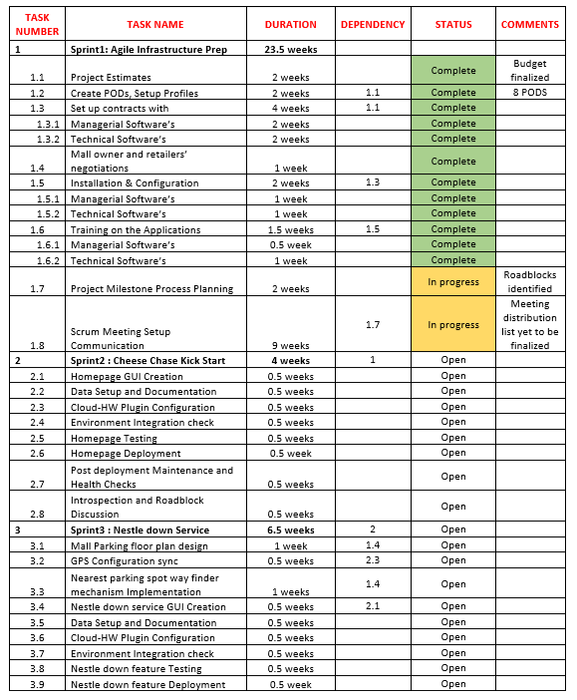

**Network Diagram :**

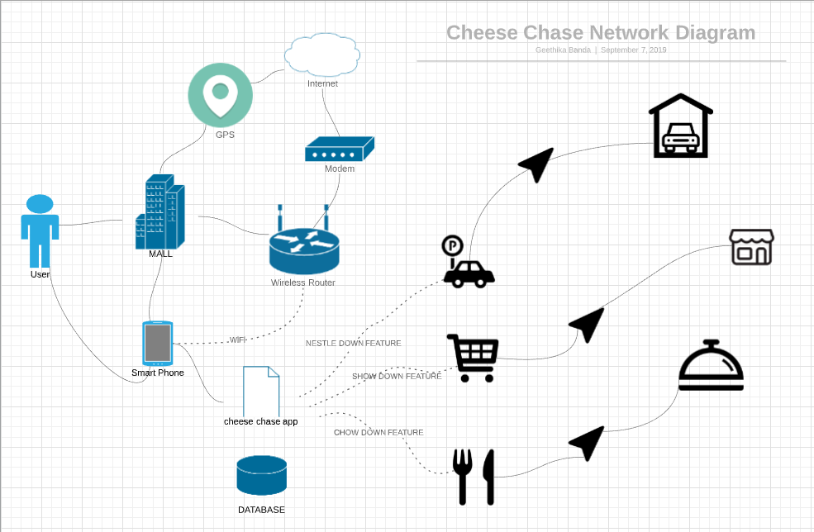

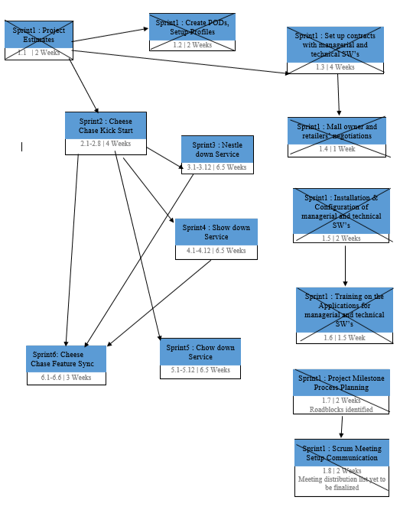

**Gantt Chart :**

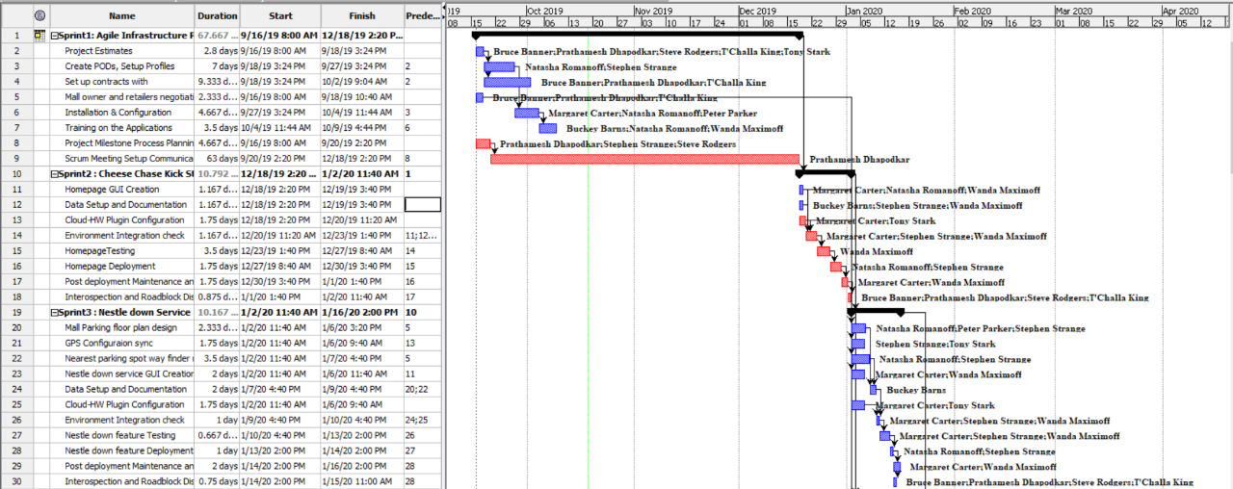

**Domain Model :**

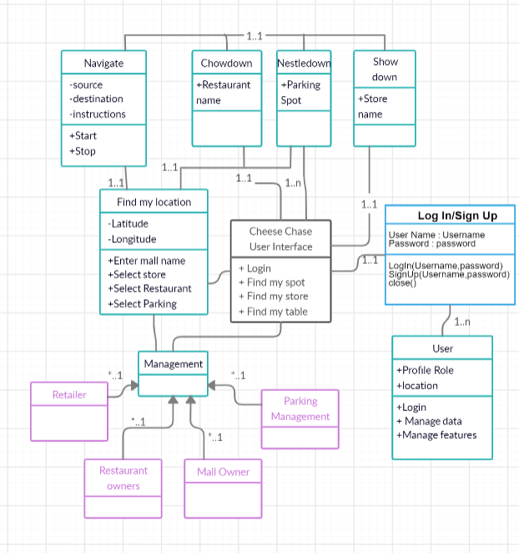

1. **Business Requirements**

**On managerial front:** Cheese Chase will be developed in an agile methodology which includes reporting to the managers according to the new POD structures. Managing the project dashboards, timelines and Roadblocks with JIRA and Confluence Software. Conduct daily scrum meetings, run project estimate tool and update them on all the platforms for every sprint.

**On technical front:** Software contracts with JIRA and Confluence, AWS Cloud, Android and IOS, Jibestream’s mapping and location technology and Inpixon's Indoor IPA technology, IPA sensors, video surveillance solutions, Wireless connectivity assurances, Google GPS offerings, Mendix App creating solutions, IBM Systems, Skype for Business and PeopleSoft Systems.

**Staffing:** The key members of this project are as follows combined together forms the scrum team in the agile methodology.



* Project Manager
* Business lead
* Tech Lead
* Business Analysts
* Testing Manager
* AWS Architects
* Solutions consultants
* Subject Matter Experts
* Software Developers
* HR Manager
* Infrastructure Manager

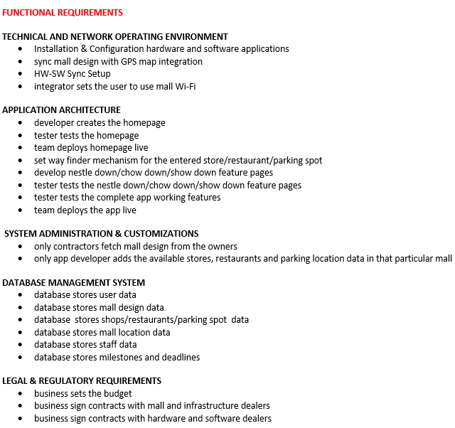

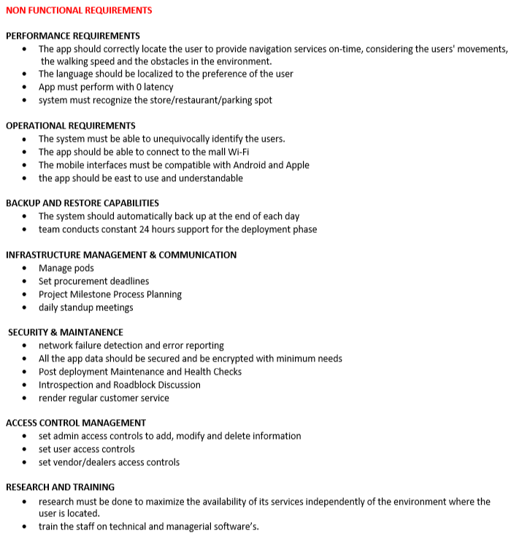

1. **Business Process and Functional Modeling**

**Use Case Diagram :**

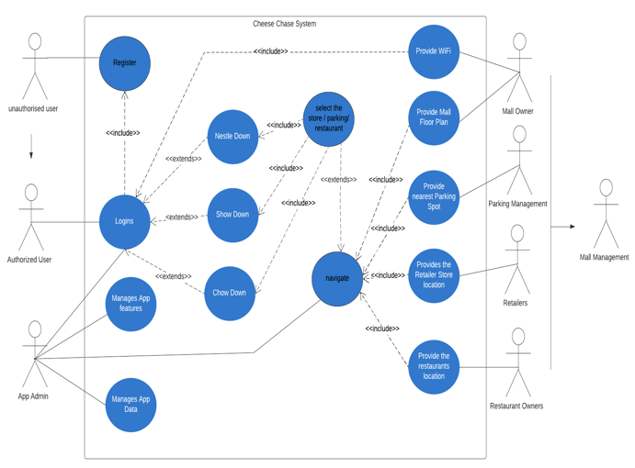

**Activity Diagram :**

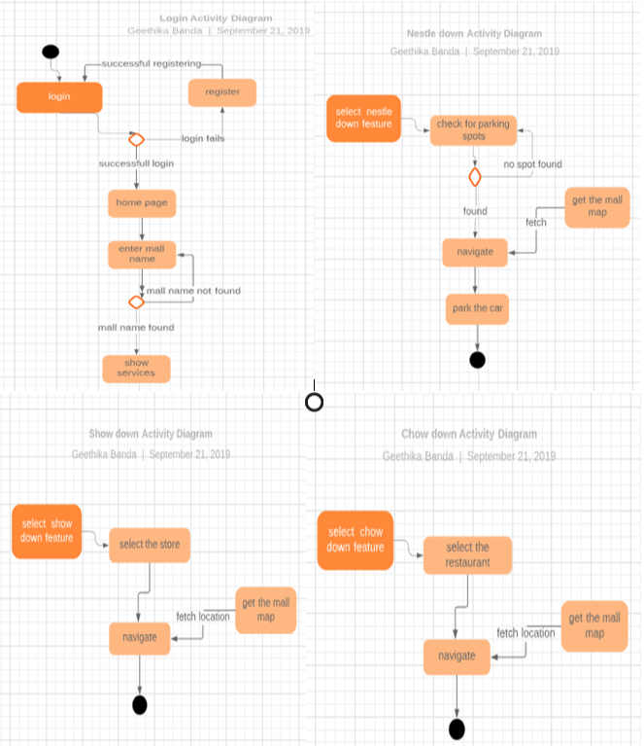

1. **Structural Modeling**

**Class Diagram :**

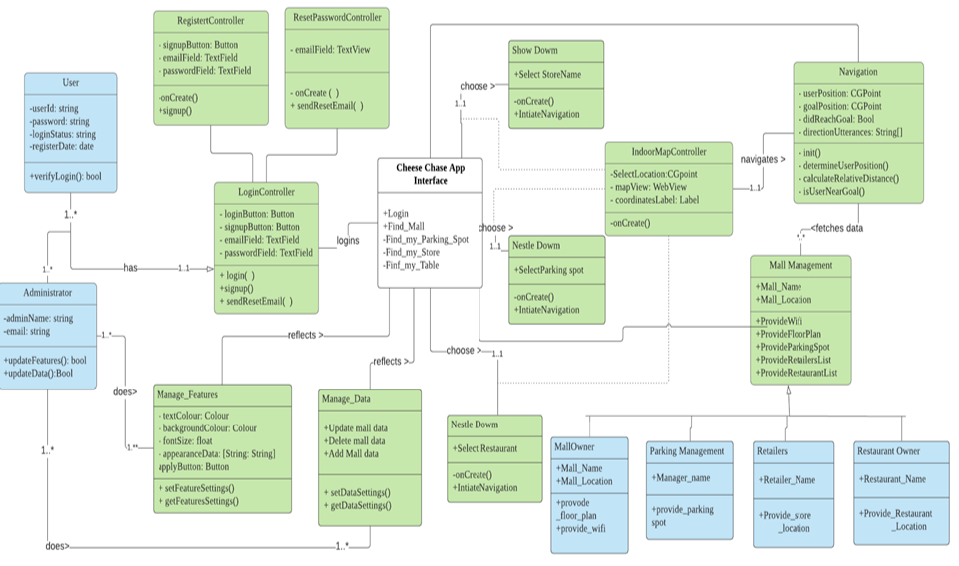

1. **Behavioral Modeling**

**Sequence Diagram :**

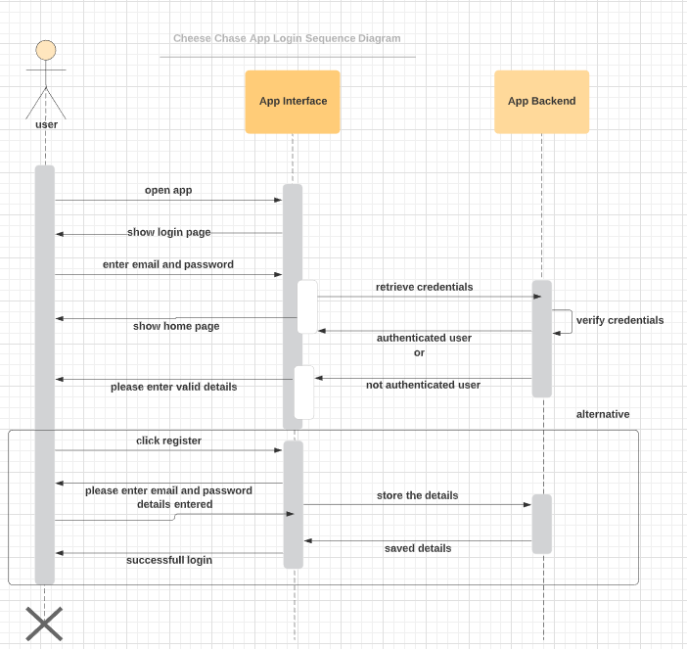

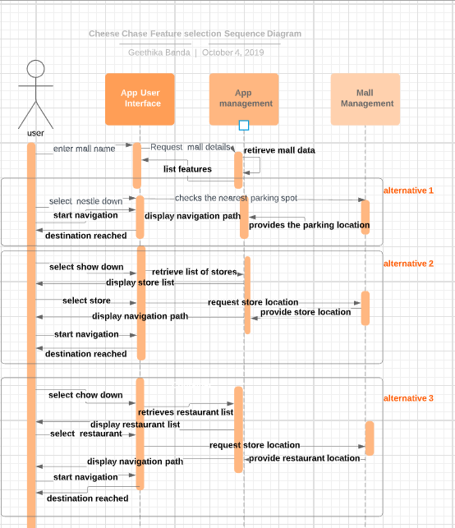

**Sequence Diagram:**

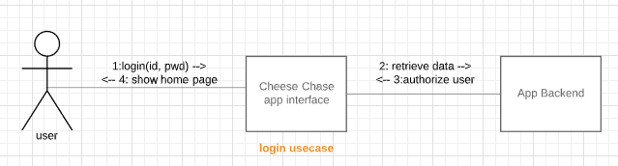

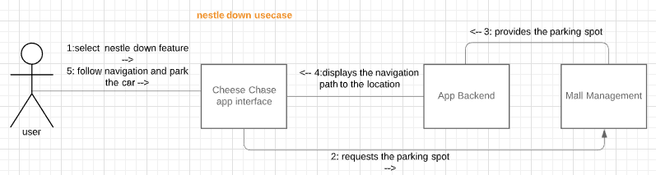

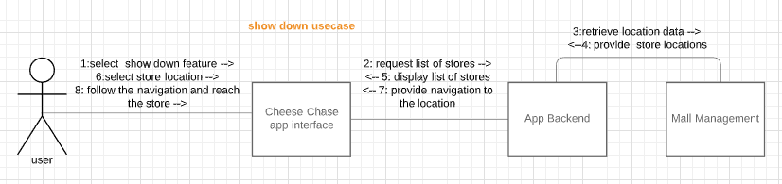

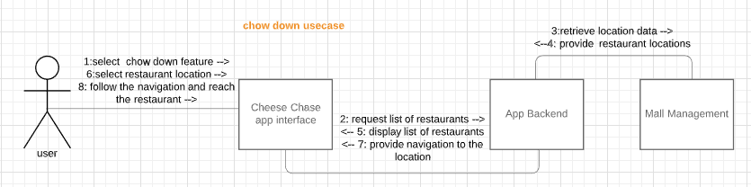

**Behavioral state machine diagram**:

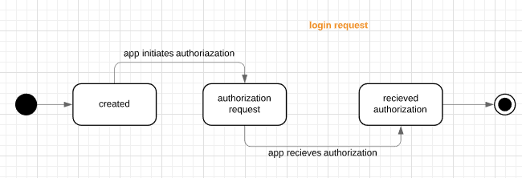

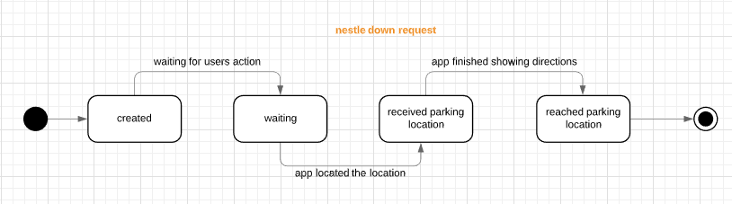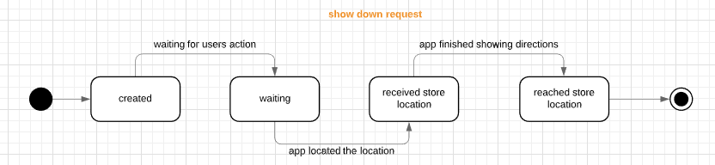

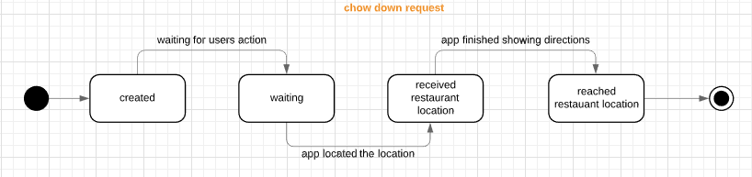

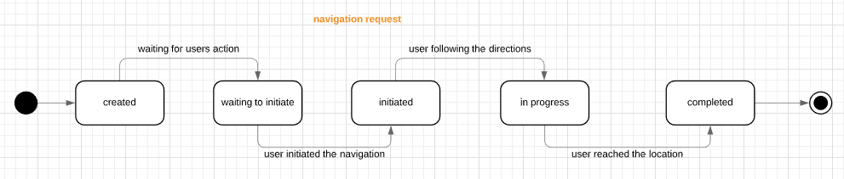

**CRUDE Analysis :**

Nestle down Use case:

|  |  |  |  |  |
| --- | --- | --- | --- | --- |
|  | **User** | **App GUI** | **App backend** | **Mall Management** |
| **User** |  | **C** |  |  |
| **App GUI** |  | **U,E** | **R** |  |
| **App backend** |  |  | **E,D** | **U** |
| **Mall Management** |  |  |  |  |

Show Down Use Case :

|  |  |  |  |  |
| --- | --- | --- | --- | --- |
|  | **User** | **App GUI** | **App backend** | **Mall Management** |
| **User** |  | **C,R,U** |  |  |
| **App GUI** |  | **U,E** | **R** |  |
| **App backend** |  |  | **E,D** | **U** |
| **Mall Management** |  |  |  |  |

Chow Down Use Case:

|  |  |  |  |  |
| --- | --- | --- | --- | --- |
|  | **User** | **App GUI** | **App backend** | **Mall Management** |
| **User** |  | **C,R,U** |  |  |
| **App GUI** |  | **U,E** | **R** |  |
| **App backend** |  |  | **E,D** | **U** |
| **Mall Management** |  |  |  |  |

1. **Application Designing**

**Package Diagram :**

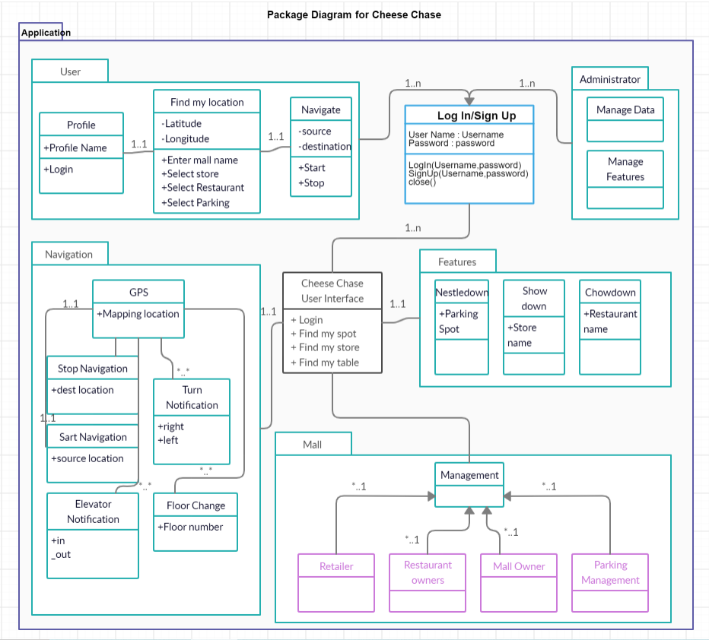

1. **Application Architecture and Data Management**

On the technical front, once the User enters the mall, he connects to the mall wi-fi and opens the cheese chase application. The user class based on the profile role( guest, admin) interacts with the login page. He then enters his username and password to login to the application or signs up for it if he is a first time user. The cheese chase interface will ask the user to enter the mall name and feeds its location to the memory as a source, it then retrieves the data containing the floor plan, list of retailer stores and eateries with its respective locations. When the user finds the store he needs to go, he then starts the navigation and the application will provide the navigation towards the destined location with turn by turn alerts in the shortest path possible.

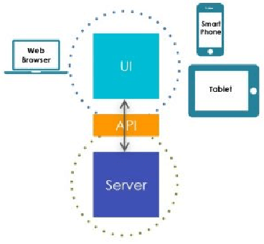

A typical application has 3 parts:

1. Client-side app component that works on the device you use, User Interface
2. Central/remote Server component that provides backend services
3. Both these components separated by well-defined REST API contract

Cheese chase uses Single-Page web Applications that load a single HTML page and dynamically update that page as the user interacts with the app where the markup and other UI artifacts are generated on the server-side for each request and sent to client.

The application enables rapid application development with clear separation of front-end and back-end development, and enables easy integration with well-defined REST APIs. This model brings separation of concerns for various layers, which form part of the app architecture.

App building process combines the ability to develop front-end by auto-generating widget code and binding to the data services. From the data model obtained from the database, back-end services with their REST API contracts are auto-generated for integration. Both the front-end and back-end layers can be integrated with the help of binding and variables, which enable data integration with various services such as DB, Web Services or any custom Java Service.

1.UI Layer is built with Pages, which are composed with widgets using visual drag-n-drop approach.

2.Binding Layer integrates backend services with the front-end UI layer through REST APIs.

3.Services Layer represents backend services auto-generated from databases, external web services or custom Java services etc.

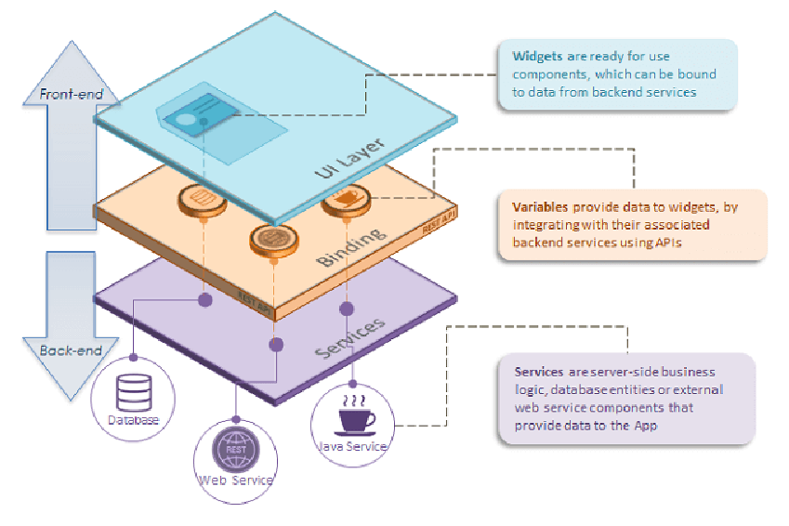

The mendix developing tool helps with efficient database usage. With this ease the data can be managed for the two type of user roles, the mall visitor and the application admin.

The database is linked as the input parameters into the microflows in which the step by step process can be specified with numerous conditioned validation and page views.

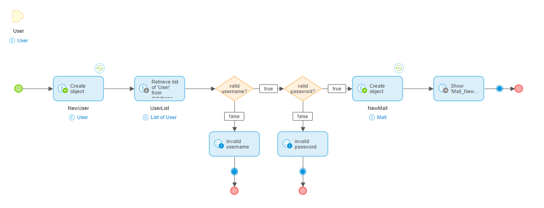

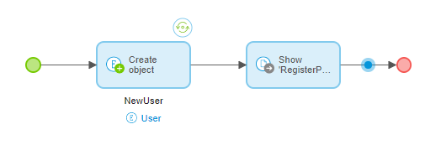

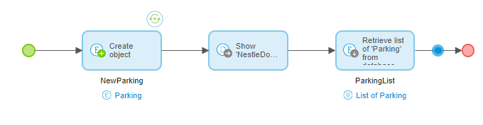

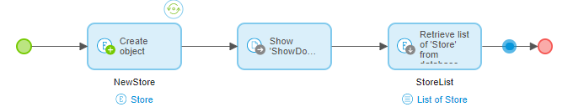

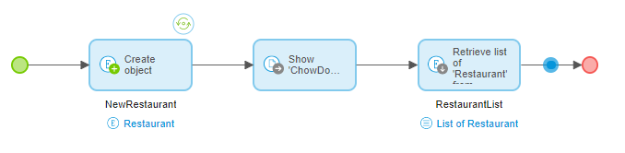

1. **Human Computer Interaction Layers**

In the age of digitization with smartphones and tablets, mobile apps are the need of the day for enterprises. Mobile apps have a farther reach and these apps would get a wider exposure and cheese chase works on Responsive Web Apps which can be built just like any other web app, with the capability to adapt their UI to the size of current browser window. It has the ability to leverage device capabilities such as the use of a camera, accessing contacts, storing a file on the device etc. and accessing the local internet facility.

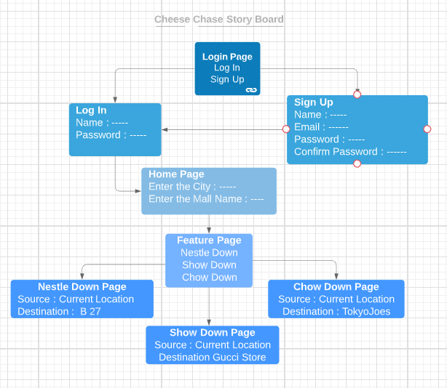

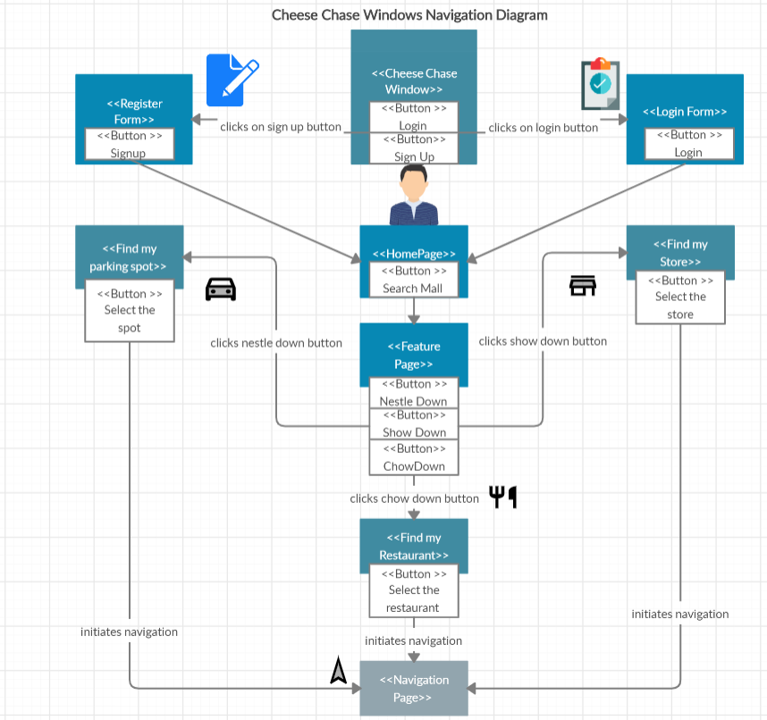

Above diagram depicts the user interface of the cheese chase application where if the user is a registered one, he can directly login, or he can sign up for the application which opens into the homepage where the runner information is given. The respective mall name and mall city is entered which opened into the services page. Once the feature has been chosen from the three services, the user can navigate to the selected parking spot or the retailer store or the restaurant following the turn by turn instructions.

**User Interface Navigation :**

The application is wi-Fi signal based which is found in any indoor environment of any mall, hence the application can be used once connected to the mall wi-fi for with all permissions are already in place which were needed to be acquired by the management to gain access to the floor maps, list of the stores and restaurants in the mall.

The implementation of the application is done on the mendix application which gives the user interface view on three planes (phone, tablet and desktop).We open the app to find the below page:

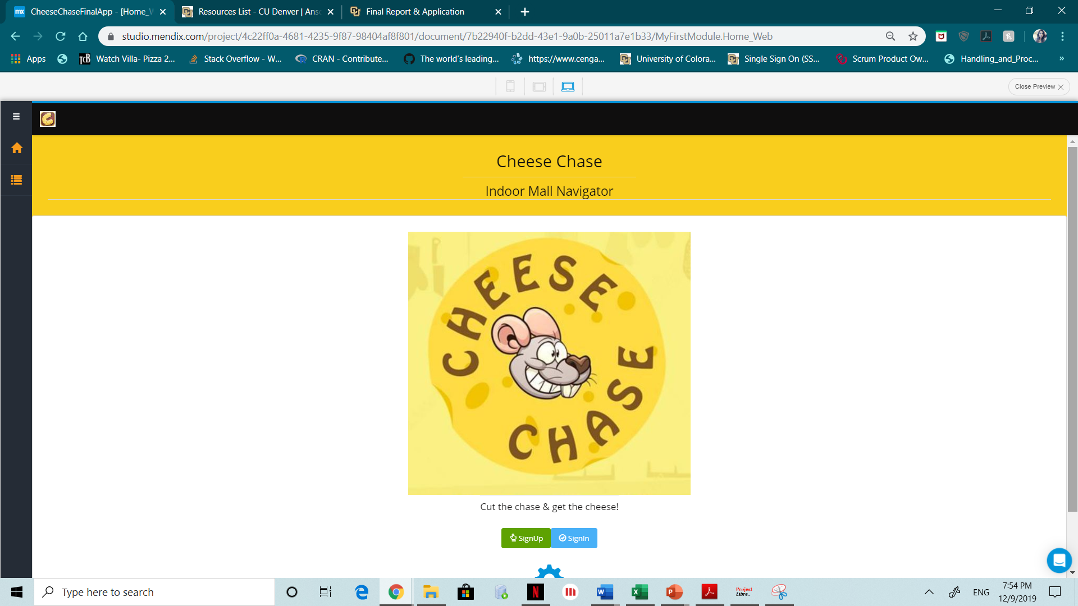

This page has two options of Sign Up and Sign In.

Sign Up: Unregistered users can log into the application by registering themselves by clicking this option.

Sign In : Registered Users login with their credentials by clicking this option.

The user punch in their credentials : name, email and password which are then saved into the database.

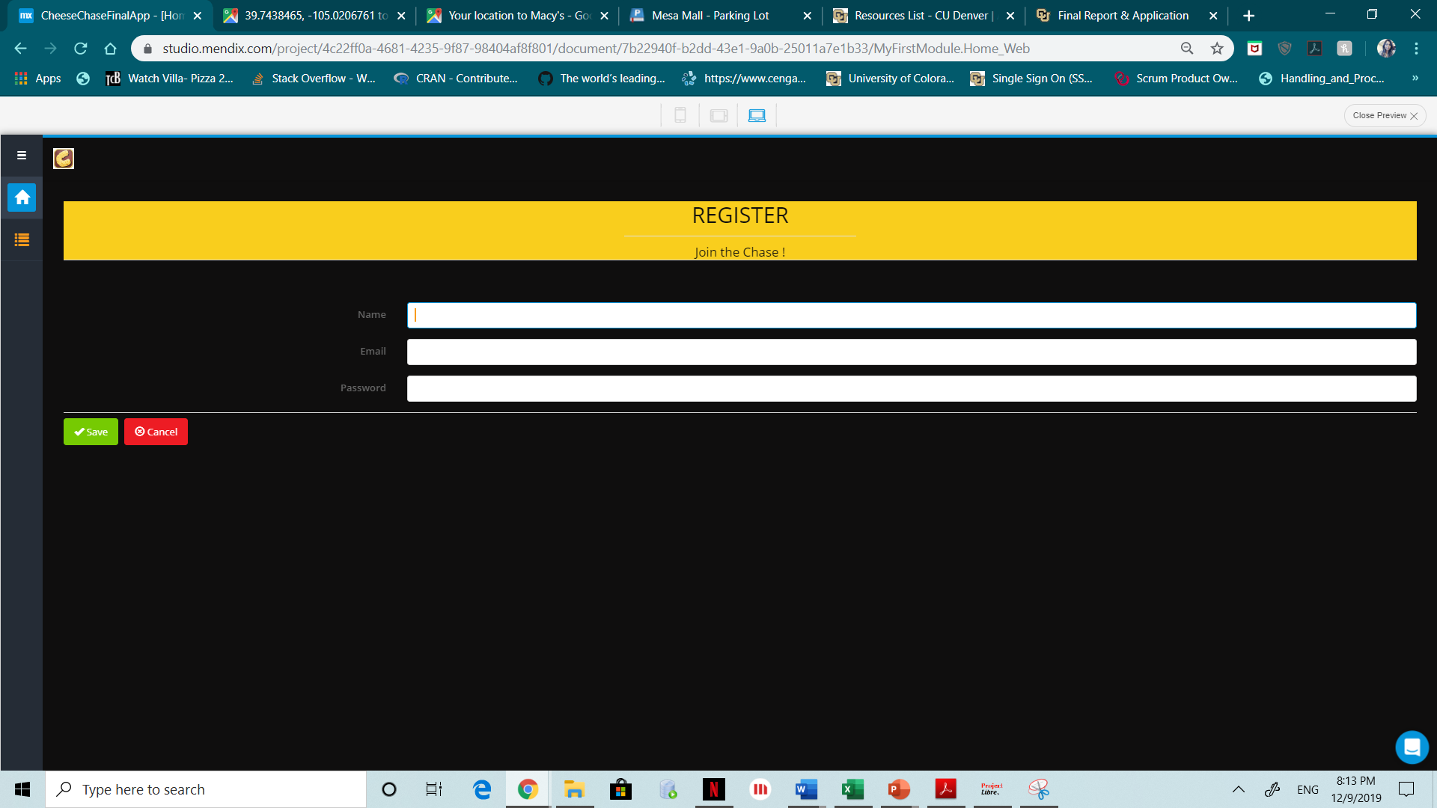

While entering the values, we view as follows :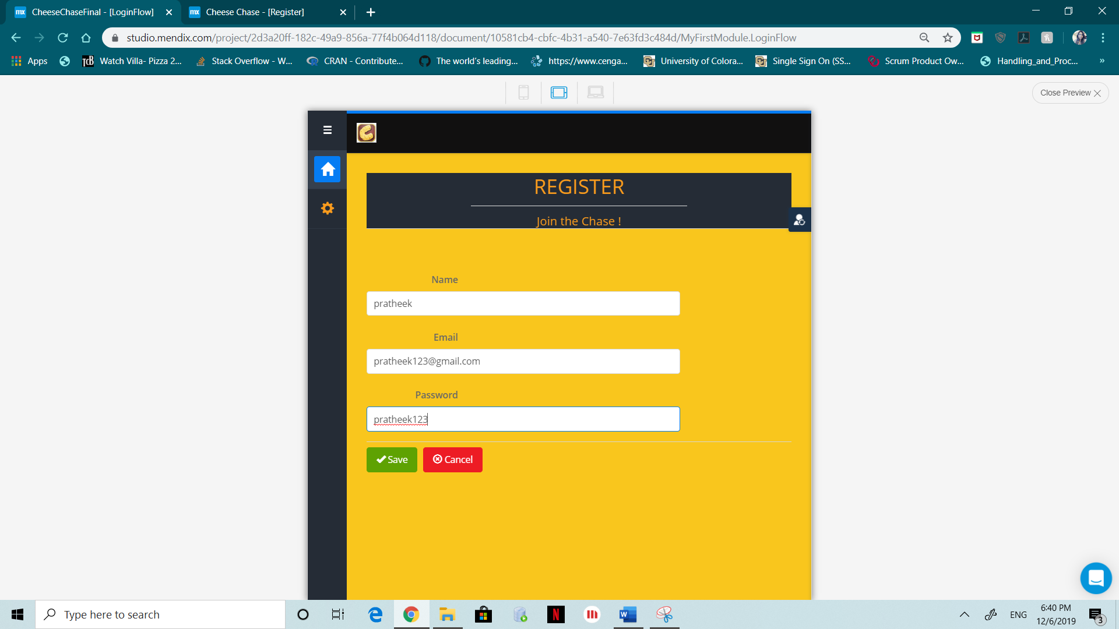

After successfully registering into the application the user is navigated to the Login page where he is authenticated into the application.

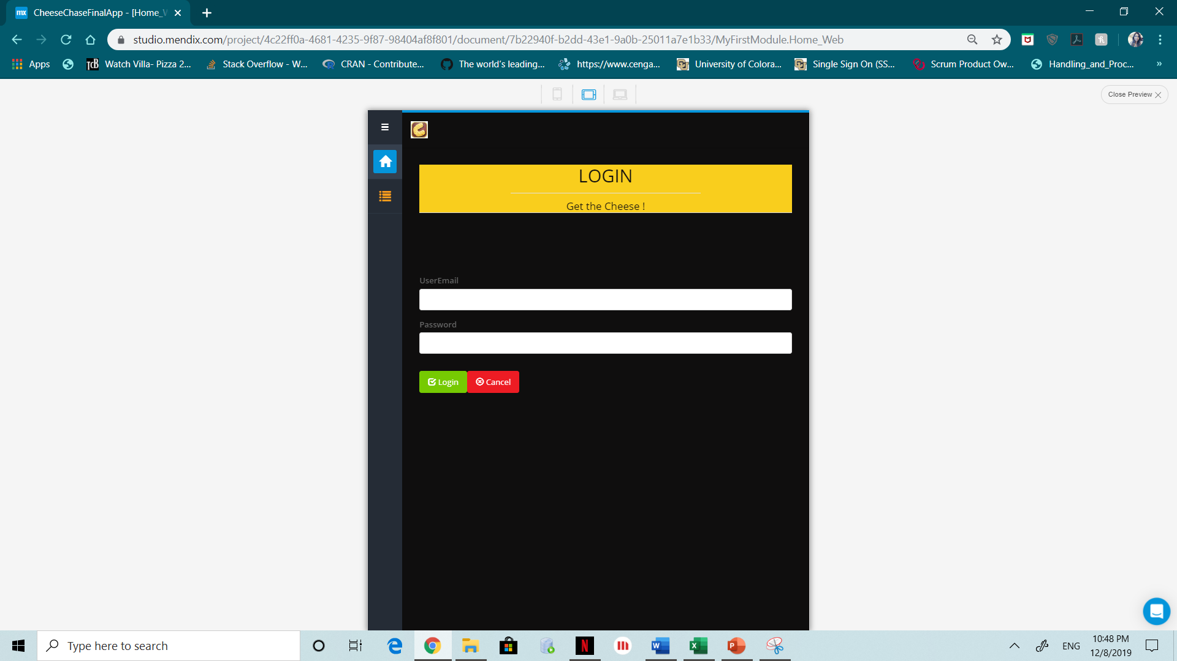

If the user enters any invalid value, it throws an error as following (Invalid username/password):

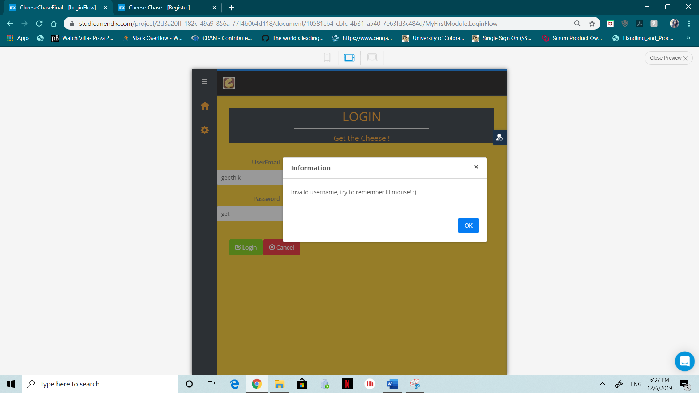

While the user enters valid credentials, we can view the page as follows:

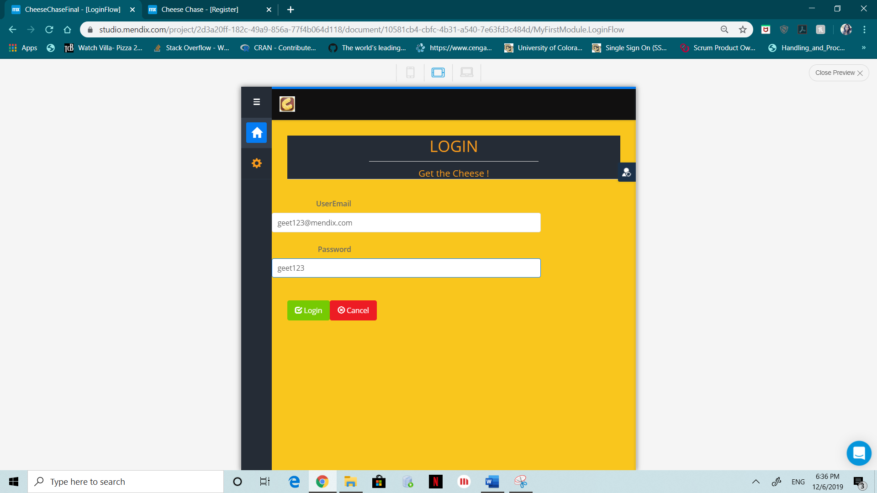

Once the user logs in successfully, he is diverted to the Runner Information Page where he enters the mall city and the mall name and the database retrieves the selected mall information.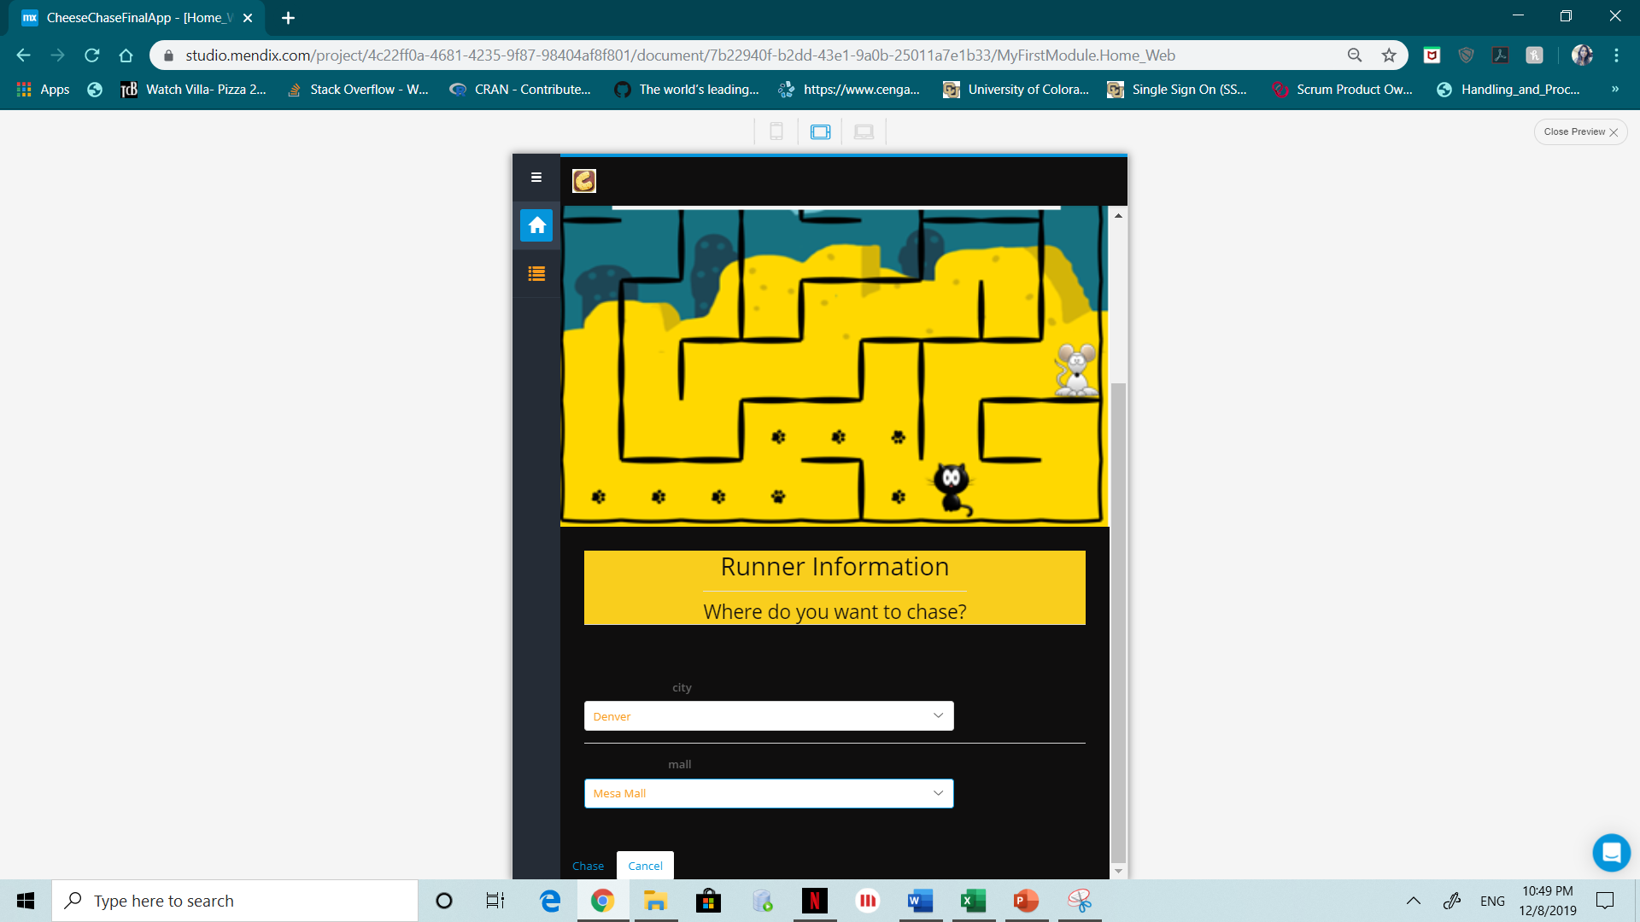

Once the runner enters the mall information, they are navigated to the Services page where you can see the three services Nestle Down, Show Down and Chow Down.

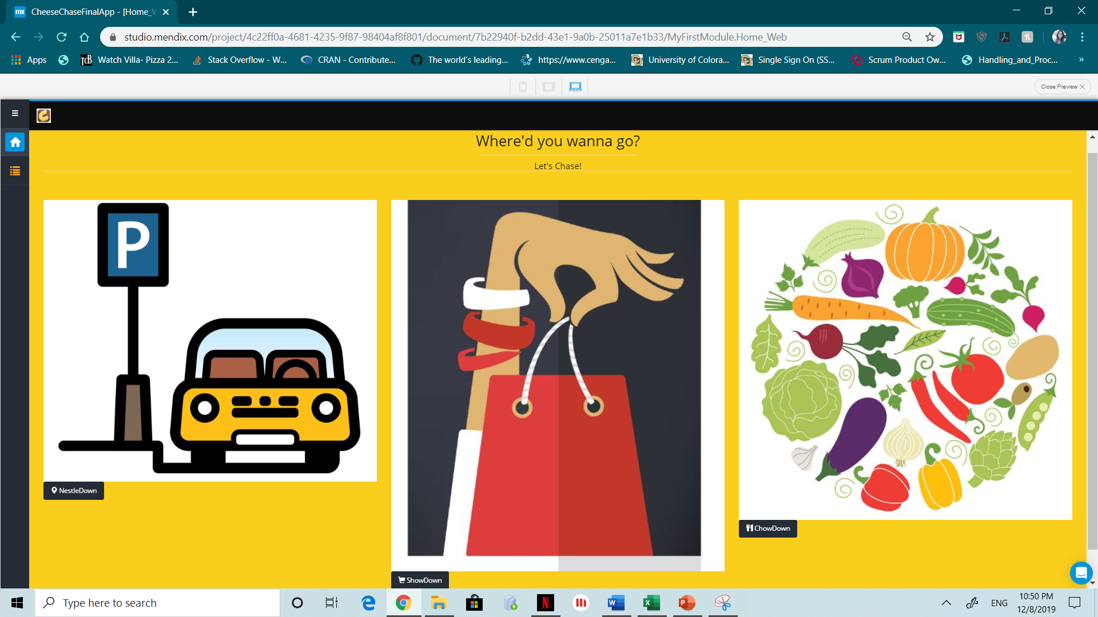If the user clicks on the nestle down potion, he is diverted to Nestle Down home page which shows the available parking spots in the mall as below :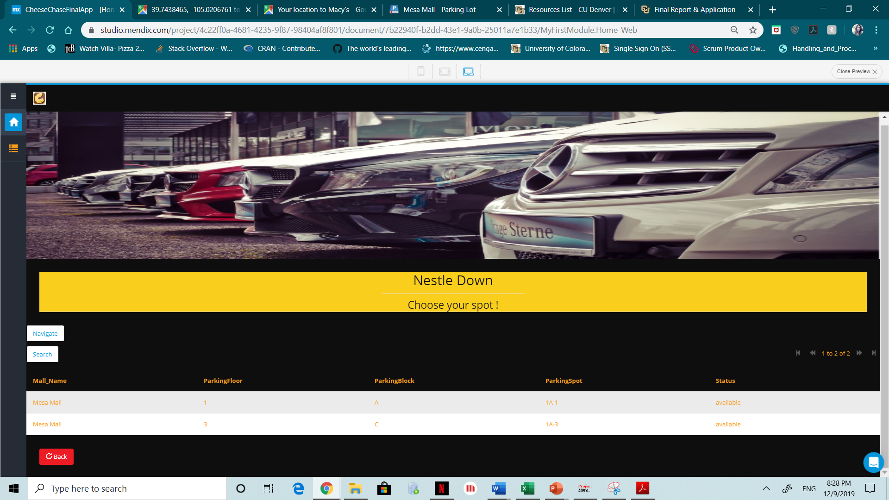

We can see that the user selected the first available spot which is highlighted and once he hits the navigate button, the application will open the navigation portal leading the user to the desired parking spot.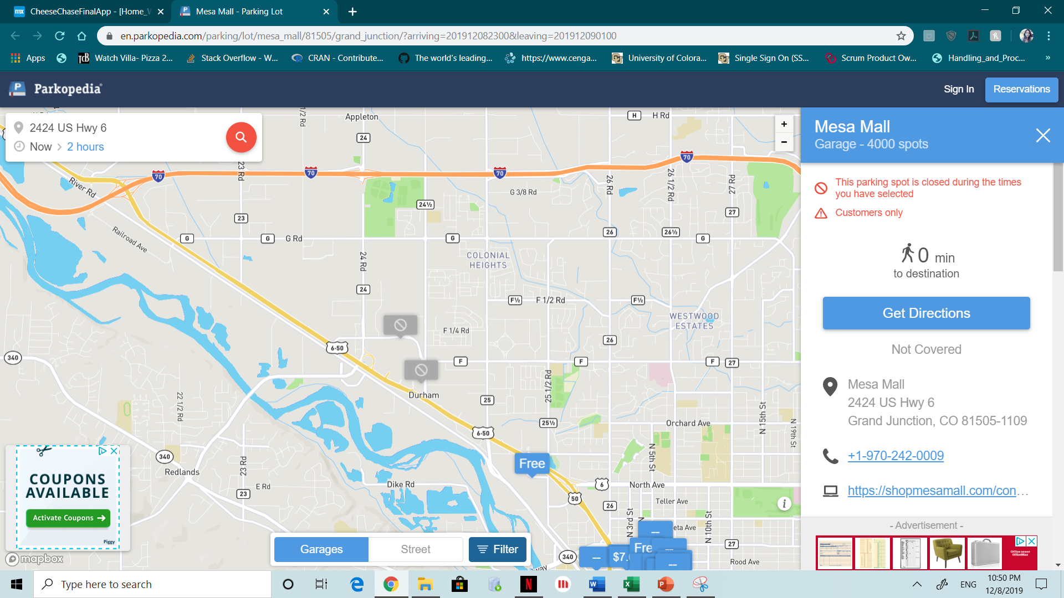If the user wants to exploring the next option ; Show Down to get to his desired store in the mall, the application opens the Show Down page as below :

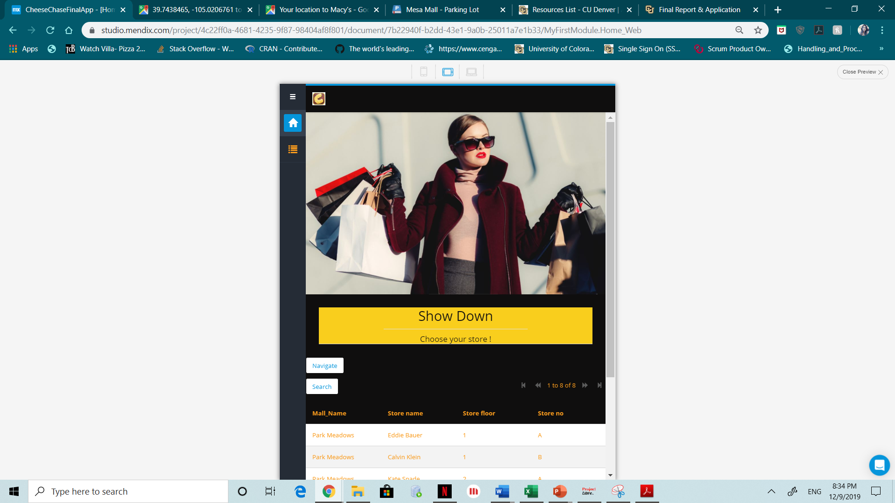

By choosing the CK option and hitting navigate button, below navigation page is popped up:

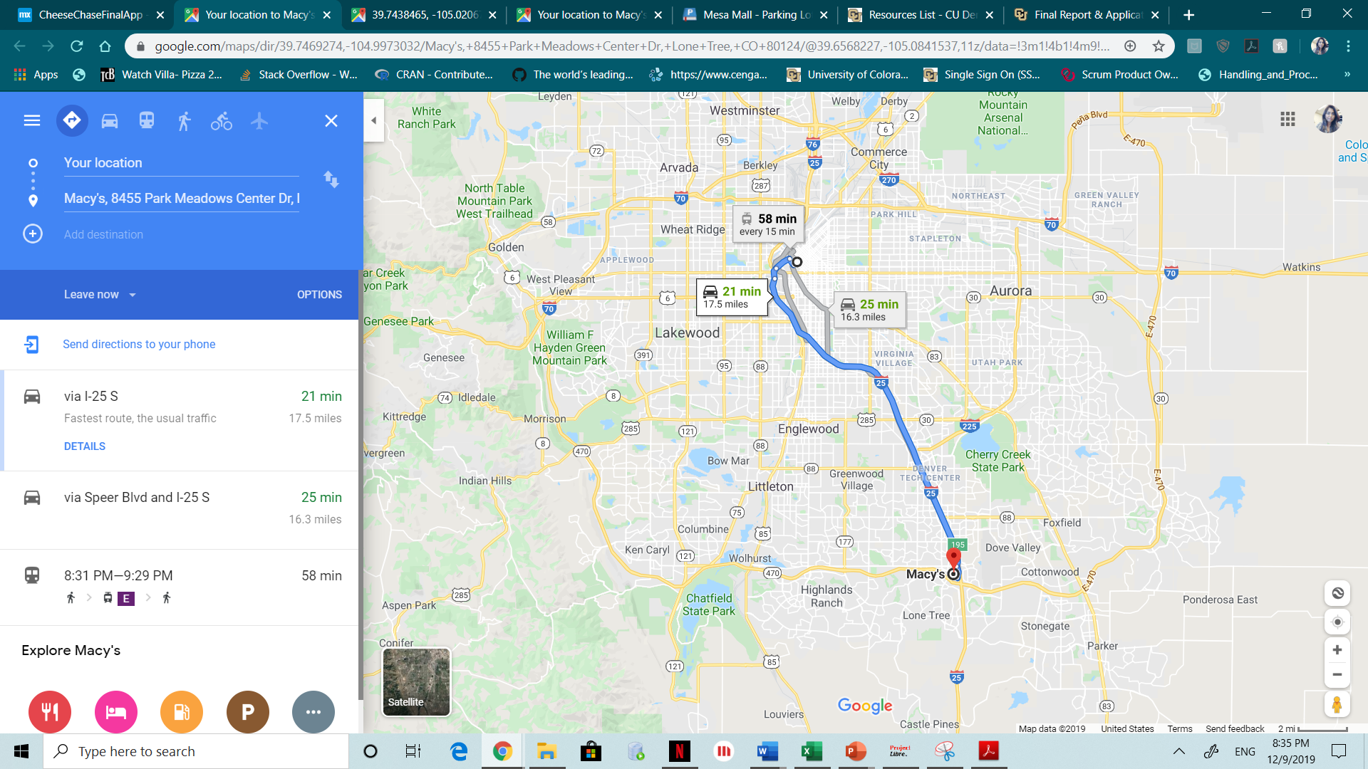Finally, the Chow Down option shows the list of restaurants in the selected mall as below :

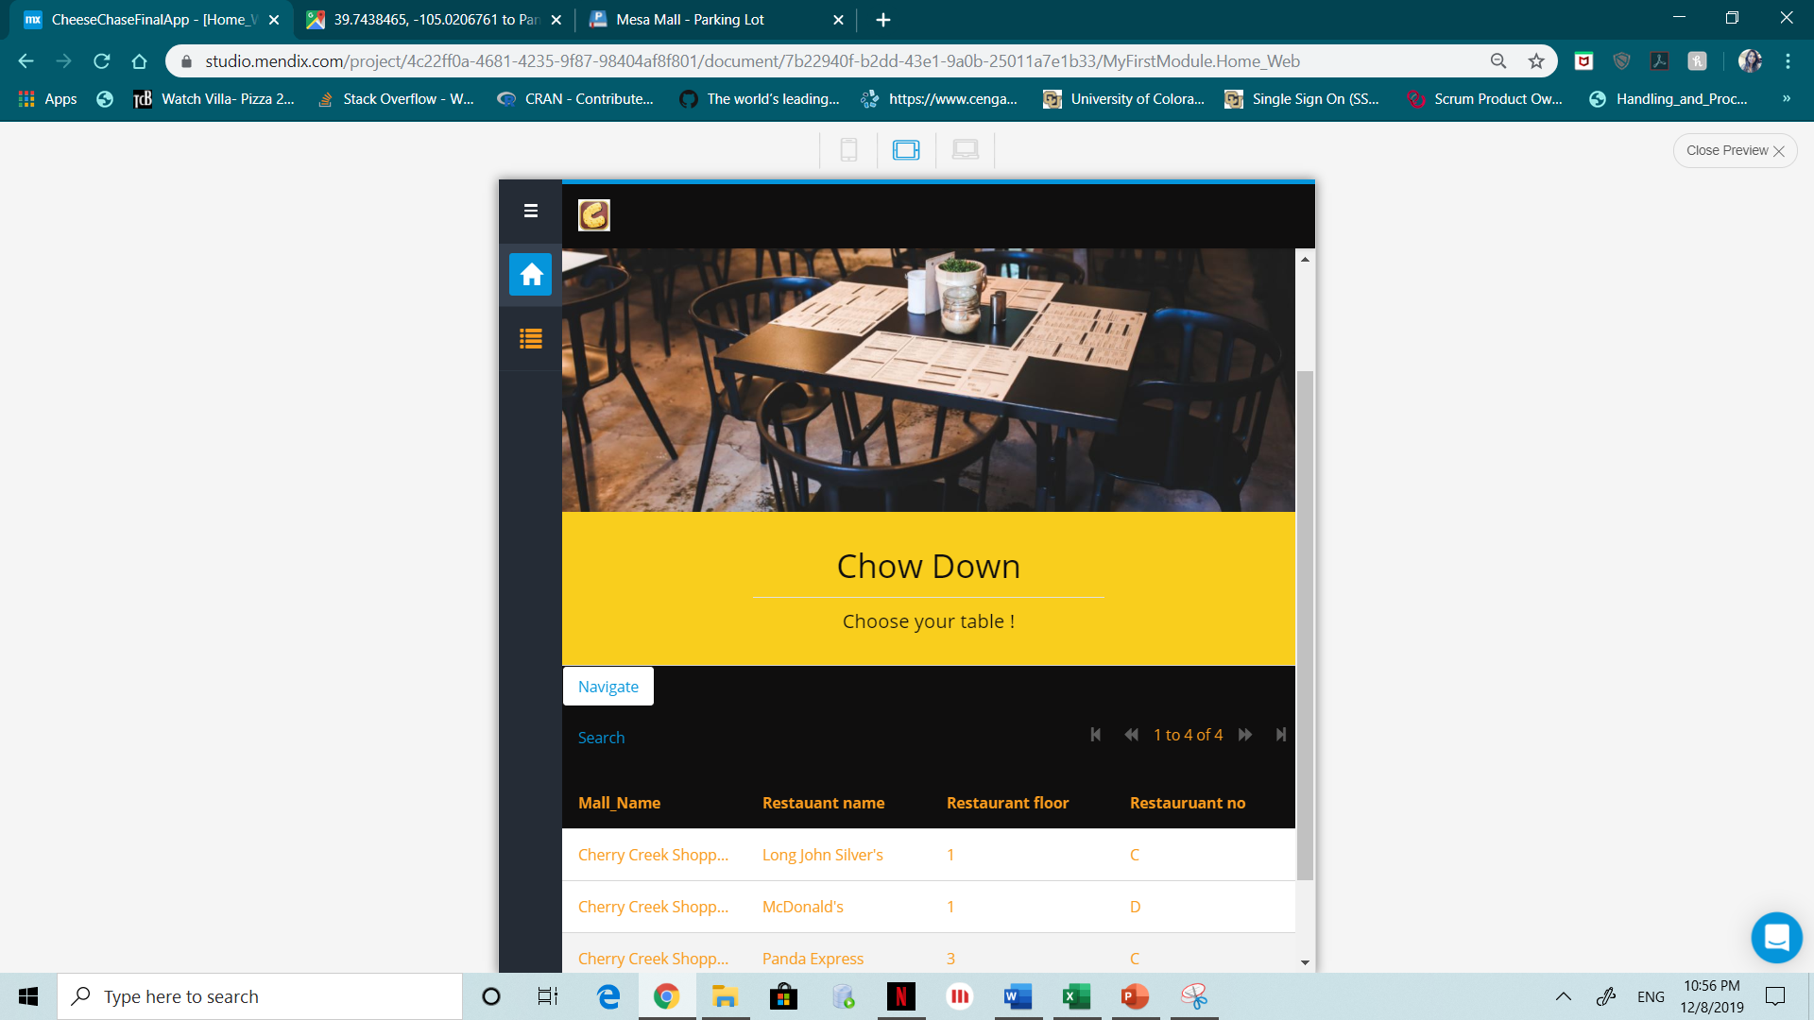

The following navigation page leads the user to the desired selected restaurant location.

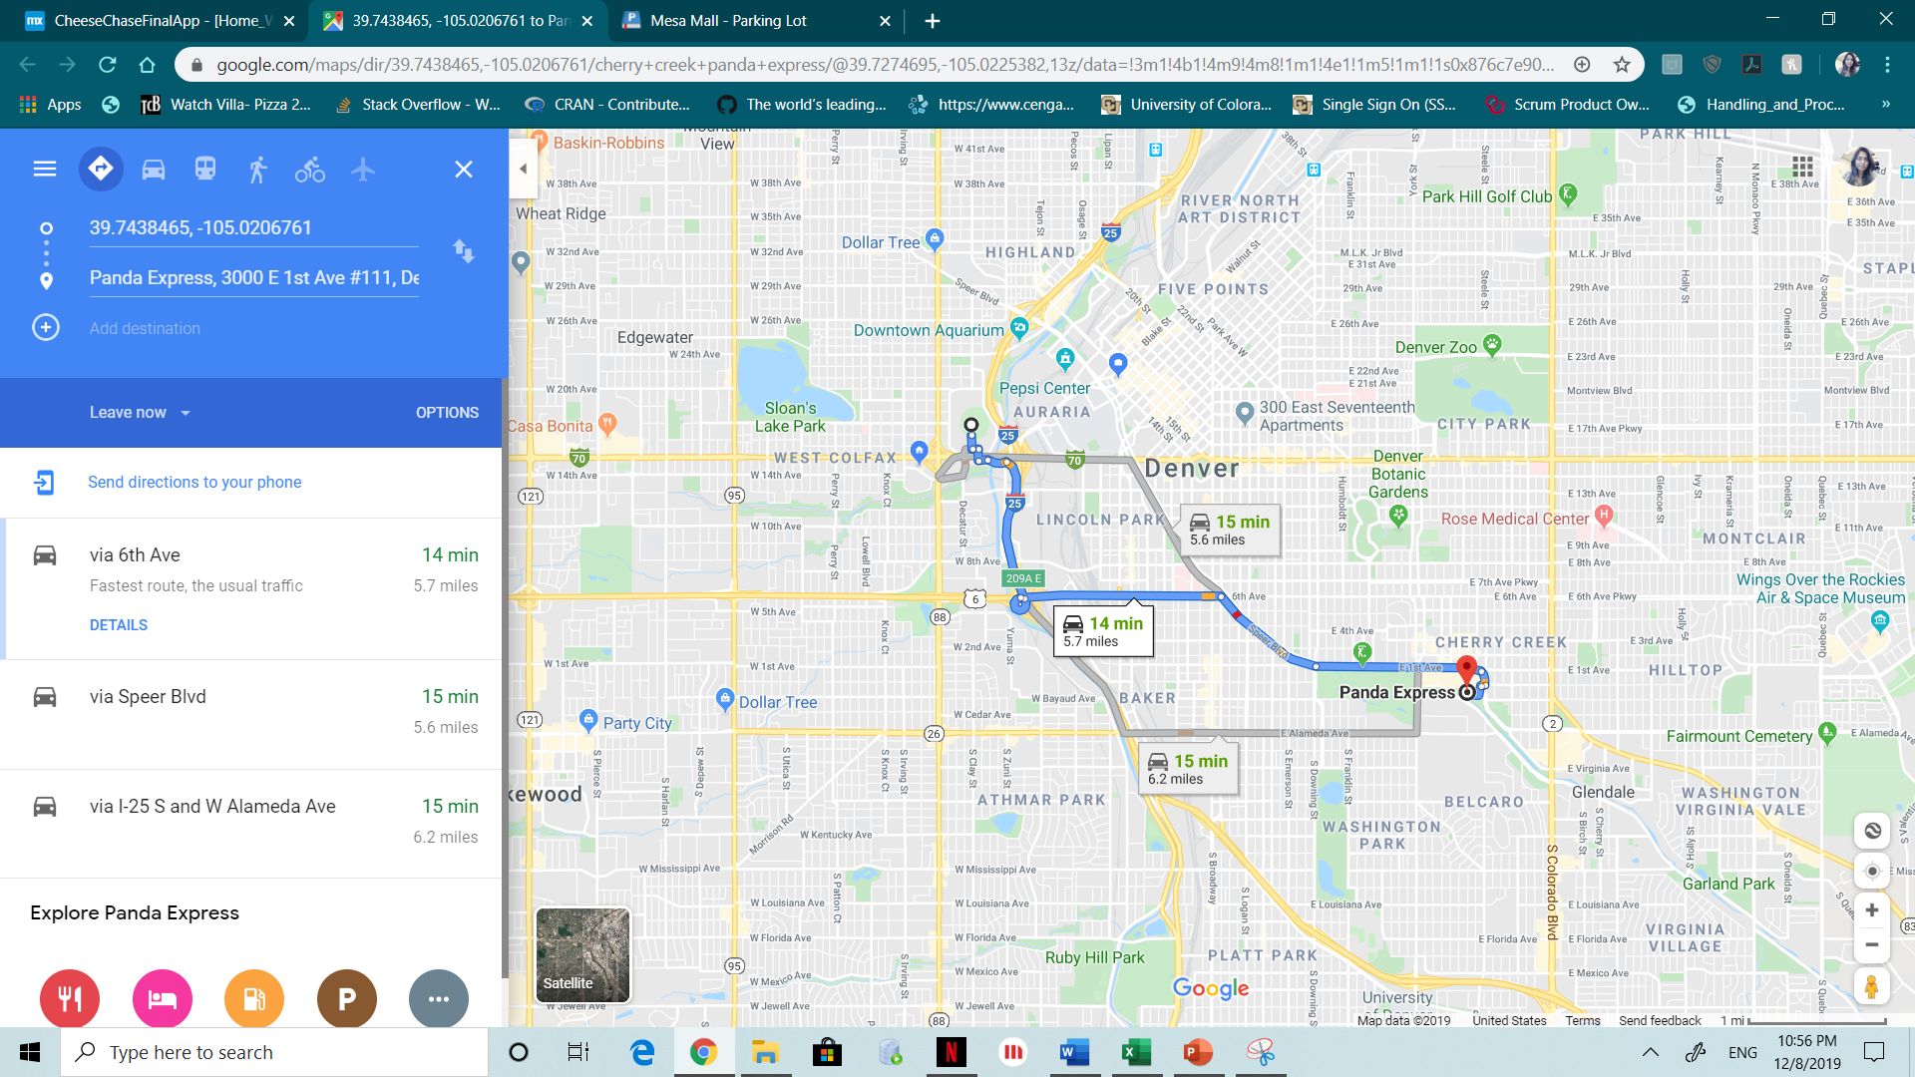

Admin can view the data of all the tables and manage them as needed in the below page.

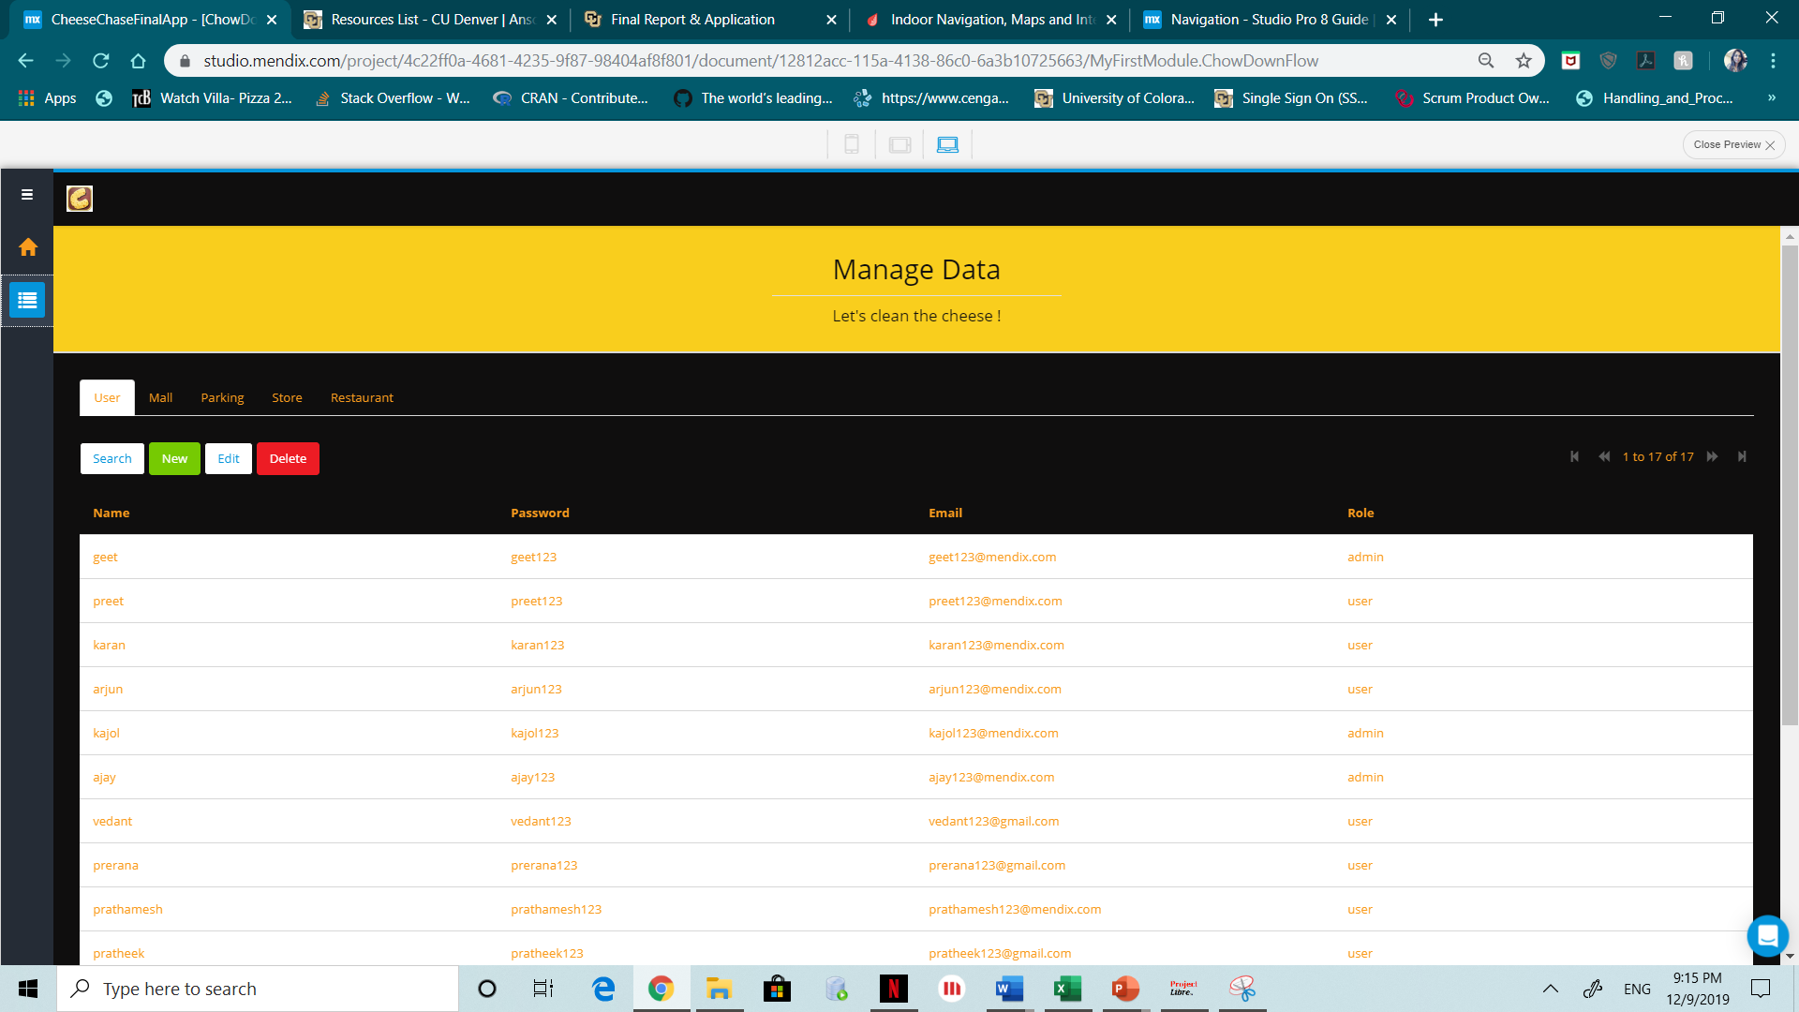

1. **Conclusion**

Cheese Chase leverages the power of location and bring order to complex data as it can also record a trace and follow it backwards to its starting point. For instance, in an unfamiliar garage, you can record a trace from your parking spot to the elevator, and later follow it in reverse to find your car. It indeed provides services which enhances the mall experience with real time store location helping everyday shoppers to their desired destination.

**Future Enhancements :**

The application considers all the users as one who can have the one role access to the application which three features and the admin can manage the data from the backend once you login. Cheese Chase is planned to extend its scalability to have role specific user interfaces like the mall management, staff, shoppers, visitors, contractors and admin. Apart from that the geospacer can also be extended to the different counties and continents to make it global used world-wide.

To make it global, we need to prepare the application a lot for global audience with following aspects like structuring the app to support localized content, translate user-visible content, advance your localization with culturalization, localize the App Store metadata and also to reach a local audience through your marketing.

**References:**

# System Analysis & Design, An object oriented approach with UML 5th edition

# (PMBOK guide) (6th Ed.) Software Project Management Plan (v1.2a) (BOTS-SPMP)

# Essays, UK. (November 2013). An Interactive Shopping Mall Navigation System.

# <https://www.jibestream.com/>

# <https://docs.mendix.com/refguide/navigation>